

Course Project Report
Subject: SWD392

– Da Nang, April 2025 –

Table of Contents
Record of Changes 3
I. Overview 4
I.1 Project Information 4
I.2 Project Team 4
II. Requirement Specification 4
II.1 Problem description 4
II.2 Major Features 4
II.3 Context Diagram 4
II.4 Nonfunction Requirements 5
II.5 Functional requirements 5
II.5.1 Actors 5
II.5.2 Use Cases 5
II.5.2 .1 Diagram(s) 5
II.5.2.2 Use case descriptions 6
II.5.3 Activity diagram 8
III. Analysis models. 9
III.1 Interaction diagrams 9
III.2 State diagram 10
IV. Design specification 11
IV.1 Integrated Communication Diagrams 11
IV.2 System High-Level Design 11
IV.3 Component and Package Diagram 11
IV.4 Class diagram 12
IV.5 Database Design 12
V. Implementation 13
V.1 Map architecture to the structure of the project 13
V.2 Map Class Diagram and Interaction Diagram to Code 13
V. Applying Alternative Architecture Patterns 13
V.1 Applying the service-oriented architecture 13
V.2 Applying Service Discovery Pattern in the service-oriented architecture 13

Record of Changes
Date | A*  M, D | In charge | Change Description
*A - Added M - Modified D - Deleted

I. Overview

I.1 Project Information
- Project name: << Real-Time Messaging And Calling System>>
- Project code: <<RMCS >>
- Group name: <<SWD392-G7>>
- Software type: <<Software Type: Web>>

I.2 Project Team
Full Name | Role | Email | Mobile
Nguyễn Phương Tâm | Lecturer | TamNP4@fe.edu.vn
Nguyễn Lương Hoàng Thiên | Member | nguyenluonghoangthien5605@gmail.com
Văn Minh Kiệt | Member | hoccuakiet@gmail.com
Lê Nguyễn Minh Tài | Member | minhtai130tgm@gmail.com
Lý Thanh Tân | Member | biltoyt@gmail.com

II. Requirement Specification

II.1 Problem description
[Gives the overall description about the product with some introduction and the context diagram. The context diagram presents the boundary and connections between the system you’re developing and everything else in the universe. This identifies external entities (or terminators – software, hardware, human components, and other systems) outside the system that interface to it in some way, as well as data, control, and material flows between the terminators and the system.]
<<Sample: The Cafeteria Ordering System is a new software system that replaces the current manual and telephone processes for ordering and picking up meals in the Process Impact cafeteria. The context diagram below illustrates the external entities and system interfaces for release 1.0. The system is expected to evolve over several releases, ultimately connecting to the Internet ordering services for several local restaurants and to credit and debit card authorization services

II.2 Major Features
[Include a numbered list of the major features of the new product, emphasizing those features that distinguish it from previous or competing products. Specific user requirements and functional requirements may be traced back to these features.]
<<Sample:
FE-01: Order and pay for meals from the cafeteria menu to be picked up or delivered.
FE-02: Order and pay for meals from local restaurants to be delivered.
FE-03: Create, view, modify, and cancel meal subscriptions for standing or recurring meal orders, or for daily special meals.
FE-04: Create, view, modify, delete, and archive cafeteria menus.
FE-05: View ingredient lists and nutritional information for cafeteria menu items.

II.3 Context Diagram
[Context Diagram is the highest-level system analysis diagram, showing the system as a "black box" with:
External entities interacting with the system
Data flows into and out of the system]

II.4 Nonfunctional requirements
[Provide the descriptions for the functions which have no UI (or not screens), i.e batch/cron job, service, API, etc.]
# | Feature | System Function | Description
1 | <<Feature Name>> | <<Function Name1>> | <<Function Name1 Description>>
2 | …

II.5 Functional requirements

II.5.1 Actors

# | Actor | Description
1 | User | The registered user who has logged into the system and can perform most functions such as chatting, calling, managing profile, and sending media.
2 | Guest | Unregistered user who can only access limited functions such as registration.

II.5.2 Use Cases

II.5.2 .1 Diagram(s)

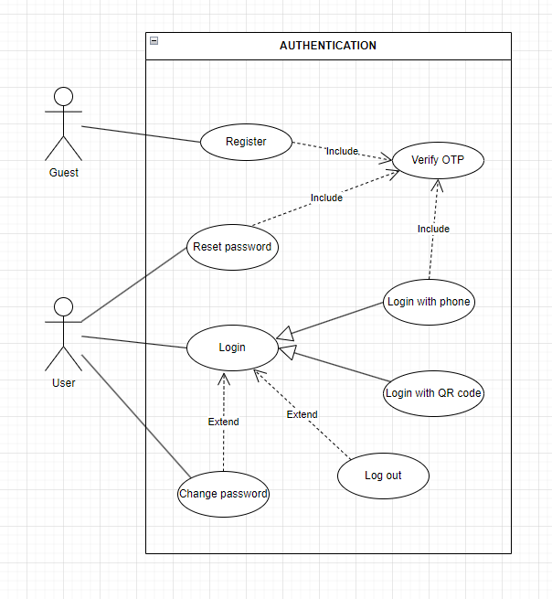

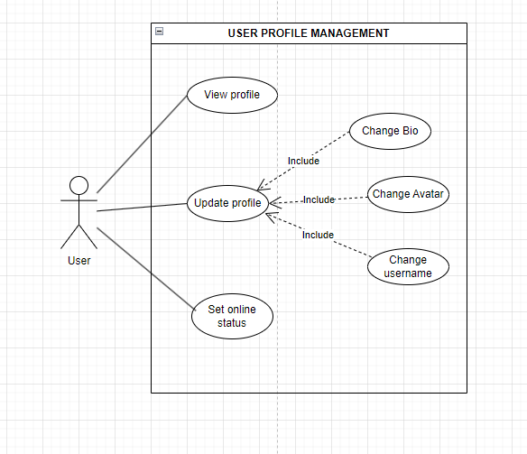

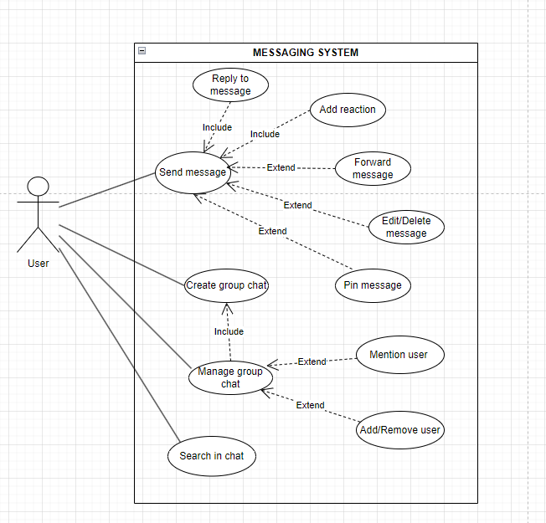

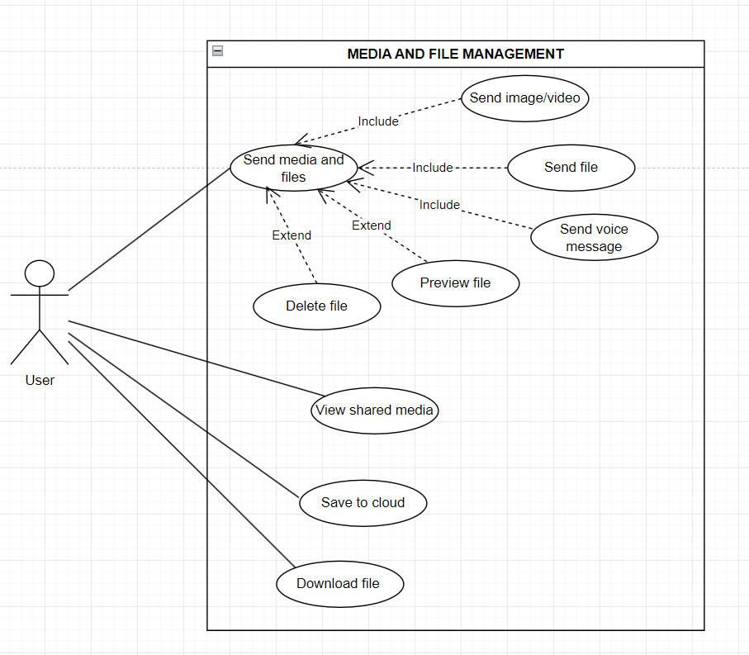

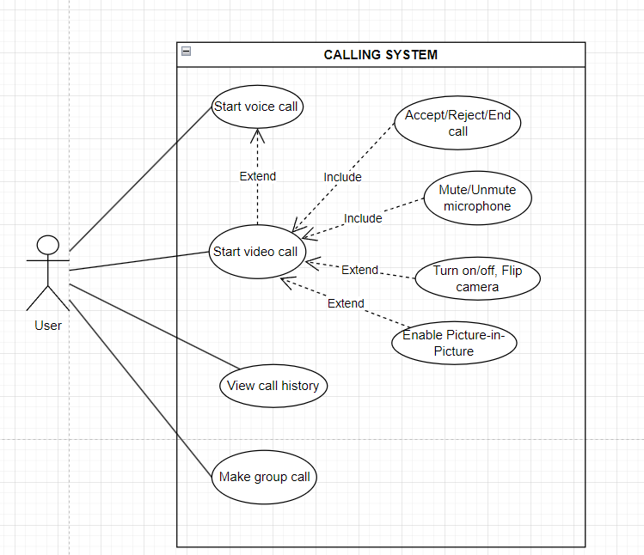

II.5.2.2 Use case descriptions

ID | Use Case | Actors | Use Case Description
UC-01 | Login with Phone + OTP | User | User logs into the system using phone number and OTP verification.
UC-02 | Register Account | Guest | Guest creates a new account using phone number and OTP.
UC-03 | Update Profile | User | User updates personal information (name, bio, avatar, username).
UC-04 | Send Message | User | User sends text messages with advanced features (reply, reaction, forward, etc.).
UC-05 | Start Voice Call | User | User initiates a voice call with another user.
UC-06 | Start Video Call | User | User initiates a video call with camera and advanced features.
UC-07 | Send Media and Files | User | User sends images, videos, voice messages, and document files.
UC-08 | Create Group Chat | User | User creates a new group chat and adds members.
UC-09 | Manage Group Chat | User | User manages group settings (add/remove members, change name, avatar).
UC-10 | Reply to Message | User | User replies to a specific message in a chat.
UC-11 | Add Reaction | User | User adds emoji reaction to a message.
UC-12 | Forward Message | User | User forwards a message to another chat.
UC-13 | Edit Message | User | User edits a sent message (within time limit).
UC-14 | Delete Message (For Everyone) | User | User deletes a message for all participants.
UC-15 | Pin Message | User | User pins an important message in the chat.
UC-16 | Mention User | User | User mentions (@) another user in group chat.
UC-17 | Search in Chat | User | User searches for messages, media, or files within chats.
UC-18 | Save to Cloud (Saved Messages) | User | User saves messages or files to personal cloud storage.
UC-19 | View Shared Media | User | User views all media and files shared in a conversation.
UC-20 | View Call History | User | User views history of all voice and video calls.

1. UC-01: Login with Phone + OTP
UC ID and Name: | UC-01 - Login with Phone + OTP
Created By: |  | Date Created:
Primary Actor: | User | Secondary Actors:
Field | Content
Trigger: | User opens the web application and wants to access their account.
Description: | User logs into the system using phone number and OTP verification.
Preconditions: | User has already registered an account with a valid phone number.
Postconditions: | User is successfully authenticated and redirected to the main dashboard.
Normal Flow: | 1. Enter phone number.  2. System sends OTP.  3. Enter OTP.  4. System validates and logs in.
Alternative Flows: | User chooses Login with QR Code.
Exceptions: | Invalid OTP (after 5 attempts), Phone number not registered.
Priority: | High - Must Have
Frequency of Use: | High
Business Rules: | BR-01
Other Information: | -
Assumptions: | Integrated with SMS Gateway.

2. UC-02: Register Account

UC ID and Name: | UC-02: Register Account
Created By: |  | Date Created:
Primary Actor: | Guest | Secondary Actors:
Field | Content
Trigger: | User wants to modify personal information.
Description: | User updates profile details including name, bio, avatar, and username.
Preconditions: | User is logged in.
Postconditions: | Profile information is updated and visible to others.
Normal Flow: | 1. Navigate to Profile page.  2. Edit desired fields.  3. Save changes.
Alternative Flows: | -
Exceptions: | Username already taken.
Priority: | High - Must Have
Frequency of Use: | Medium
Business Rules: | BR-03
Other Information: | -
Assumptions: | -

3. UC-03: Update Profile

UC ID and Name: | UC-03: Update Profile
Created By: |  | Date Created:
Primary Actor: | User | Secondary Actors:
Field | Content
Trigger: | User wants to modify personal information.
Description: | User updates profile details including name, bio, avatar, and username.
Preconditions: | User is logged in.
Postconditions: | Profile information is updated and visible to others.
Normal Flow: | 1. Navigate to Profile page.  2. Edit desired fields.  3. Save changes.
Alternative Flows: | -
Exceptions: | Username already taken.
Priority: | High - Must Have
Frequency of Use: | Medium
Business Rules: | BR-03
Other Information: | -
Assumptions: | -

4. UC-04: Send Message

UC ID and Name: | UC-04: Send Message
Created By: |  | Date Created:
Primary Actor: | User | Secondary Actors:
Field | Content
Trigger: | User wants to send a message in a chat.
Description: | User sends text messages with support for reply, reaction, forward, edit, and delete.
Preconditions: | User is logged in and inside a chat room.
Postconditions: | Message is sent and delivered in real-time.
Normal Flow: | 1. Type message.  2. Click send.
Alternative Flows: | Add reaction, reply, or forward message.
Exceptions: | Message too long or network error.
Priority: | High - Must Have
Frequency of Use: | Very High
Business Rules: | BR-04
Other Information: | -
Assumptions: | Real-time connection via WebSocket.

UC-05: Start Voice Call

UC ID and Name: | UC-05: Start Voice Call
Created By: |  | Date Created:
Primary Actor: | User | Secondary Actors:
Field | Content
Trigger: | User clicks the voice call button.
Description: | User initiates a voice call with another user.
Preconditions: | Both users are online.
Postconditions: | Voice call is established.
Normal Flow: | 1. Select contact.  2. Click voice call.  3. Wait for acceptance.
Alternative Flows: | -
Exceptions: | Recipient offline or rejects call.
Priority: | High - Must Have
Frequency of Use: | Medium
Business Rules: | BR-05
Other Information: | -
Assumptions: | WebRTC supported.

UC-06: Start Video Call

UC ID and Name: | UC-06: Start Video Call
Created By: |  | Date Created:
Primary Actor: | User | Secondary Actors:
Field | Content
Trigger: | User clicks the video call button.
Description: | User initiates a video call with camera and advanced features.
Preconditions: | Both users are online.
Postconditions: | Video call session is established.
Normal Flow: | 1. Select contact.  2. Click video call.  3. Wait for acceptance.
Alternative Flows: | Can switch to voice call.
Exceptions: | Recipient rejects or has no camera permission.
Priority: | High – Must Have
Frequency of Use: | Medium
Business Rules: | BR-05
Other Information: | -
Assumptions: | WebRTC supported.

UC-07: Send Media and Files

UC ID and Name: | UC-07: Send Media and Files
Created By: |  | Date Created:
Primary Actor: | User | Secondary Actors:
Field | Content
Trigger: | User wants to share media or documents.
Description: | User sends images, videos, voice messages, and document files.
Preconditions: | User is in a chat.
Postconditions: | Files are uploaded and shared successfully.
Normal Flow: | 1. Click attach button.  2. Select file or media.  3. Send.
Alternative Flows: | -
Exceptions: | File size exceeds limit.
Priority: | High - Must Have
Frequency of Use: | High
Business Rules: | BR-06
Other Information: | -
Assumptions: | Cloud storage is available.

UC-08: Create Group Chat

UC ID and Name: | UC-08: Create Group Chat
Created By: |  | Date Created:
Primary Actor: | User | Secondary Actors:
Field | Content
Trigger: | User wants to create a group conversation.
Description: | User creates a new group chat, sets name, avatar and adds members.
Preconditions: | User is logged in.
Postconditions: | Group chat is created and members are notified.
Normal Flow: | 1. Click create group.  2. Set group name and avatar.  3. Add members.
Alternative Flows: | -
Exceptions: | -
Priority: | High - Must Have
Frequency of Use: | Medium
Business Rules: | BR-07
Other Information: | -
Assumptions: | -

UC ID and Name: | UC-09: Manage Group Chat
Created By: |  | Date Created:
Primary Actor: | User | Secondary Actors:
Field | Content
Trigger: | User wants to manage group settings.
Description: | User adds/removes members, changes group name or avatar.
Preconditions: | User is a member or admin of the group.
Postconditions: | Group settings are updated.
Normal Flow: | 1. Open group settings.  2. Modify members or information.
Alternative Flows: | -
Exceptions: | No permission.
Priority: | High - Must Have
Frequency of Use: | Medium
Business Rules: | BR-07
Other Information: | -
Assumptions: | -

UC-10: Reply to Message

UC ID and Name: | UC-10: Reply to Message
Created By: |  | Date Created:
Primary Actor: | User | Secondary Actors:
Field | Content
Trigger: | User wants to reply to a specific message.
Description: | User replies to a particular message in the chat.
Preconditions: | User is in a chat.
Postconditions: | Reply is shown with reference to original message.
Normal Flow: | 1. Select message and click reply.  2. Type and send reply.
Alternative Flows: | -
Exceptions: | -
Priority: | High - Must Have
Frequency of Use: | High
Business Rules: | -
Other Information: | -
Assumptions: | -

UC-11: Add Reaction

UC ID and Name: | UC-11: Add Reaction
Created By: |  | Date Created:
Primary Actor: | User | Secondary Actors:
Field | Content
Trigger: | User wants to react to a message.
Description: | User adds emoji reaction to a message.
Preconditions: | User is in a chat.
Postconditions: | Reaction is displayed on the message.
Normal Flow: | 1. Click on reaction button of the message.  2. Choose emoji.
Alternative Flows: | -
Exceptions: | -
Priority: | Medium - Should Have
Frequency of Use: | High
Business Rules: | -
Other Information: | -
Assumptions: | -

UC-12: Forward Message

UC ID and Name: | UC-12: Forward Message
Created By: |  | Date Created:
Primary Actor: | User | Secondary Actors:
Field | Content
Trigger: | User wants to forward a message.
Description: | User forwards a message to another chat or contact.
Preconditions: | User is in a chat.
Postconditions: | Message is sent to the selected destination.
Normal Flow: | 1. Select message.  2. Choose forward.  3. Select target chat.
Alternative Flows: | -
Exceptions: | -
Priority: | Medium - Should Have
Frequency of Use: | Medium
Business Rules: | -
Other Information: | -
Assumptions: | -

UC-13: Edit Message

UC ID and Name: | UC-13: Edit Message
Created By: |  | Date Created:
Primary Actor: |  | Secondary Actors:
Field | Content
Trigger: | User wants to edit a sent message.
Description: | User edits content of a previously sent message.
Preconditions: | Message is within the allowed editing time.
Postconditions: | Message is updated for all users.
Normal Flow: | 1. Select message.  2. Click edit.  3. Modify and save.
Alternative Flows: | -
Exceptions: | Time limit exceeded.
Priority: | Medium - Should Have
Frequency of Use: | Medium
Business Rules: | BR-08
Other Information: | -
Assumptions: | -

UC-14: Delete Message (For Everyone)

UC ID and Name: | UC-14: Delete Message (For Everyone)
Created By: |  | Date Created:
Primary Actor: | User | Secondary Actors:
Field | Content
Trigger: | User wants to delete a sent message.
Description: | User deletes a message for all participants.
Preconditions: | Message is within the allowed deletion time.
Postconditions: | Message is removed for everyone.
Normal Flow: | 1. Select message.  2. Choose "Delete for everyone".
Alternative Flows: | -
Exceptions: | Time limit exceeded.
Priority: | High - Must Have
Frequency of Use: | Medium
Business Rules: | BR-08
Other Information: | -
Assumptions: | -

UC-15: Pin Message

UC ID and Name: | UC-15: Pin Message
Created By: |  | Date Created:
Primary Actor: | User | Secondary Actors:
Field | Content
Trigger: | User wants to pin an important message.
Description: | User pins a message so it appears at the top of the chat.
Preconditions: | User has permission in the chat.
Postconditions: | Message is pinned.
Normal Flow: | 1. Select message.  2. Click pin.
Alternative Flows: | -
Exceptions: | -
Priority: | Medium - Should Have
Frequency of Use: | Low
Business Rules: | -
Other Information: | -
Assumptions: | -

UC-16: Mention User

UC ID and Name: | UC-16: Mention User
Created By: |  | Date Created:
Primary Actor: | User | Secondary Actors:
Field | Content
Trigger: | User wants to mention someone in group chat.
Description: | User uses @ to mention another user in a group chat.
Preconditions: | User is in a group chat.
Postconditions: | Mentioned user receives notification.
Normal Flow: | 1. Type @ followed by username.  2. Send message.
Alternative Flows: | -
Exceptions: | -
Priority: | Medium - Should Have
Frequency of Use: | Medium
Business Rules: | -
Other Information: | -
Assumptions: | -

UC-17: Search in Chat

UC ID and Name: | UC-17: Search in Chat
Created By: |  | Date Created:
Primary Actor: | User | Secondary Actors:
Field | Content
Trigger: | User wants to find old messages or media.
Description: | User searches for messages, media, or files within a chat or globally.
Preconditions: | User is logged in.
Postconditions: | Search results are displayed.
Normal Flow: | 1. Open search bar.  2. Enter keyword.
Alternative Flows: | -
Exceptions: | -
Priority: | Medium - Should Have
Frequency of Use: | Medium
Business Rules: | -
Other Information: | -
Assumptions: | -

UC-18: Save to Cloud (Saved Messages)

UC ID and Name: | UC-18: Save to Cloud (Saved Messages)
Created By: |  | Date Created:
Primary Actor: | User | Secondary Actors:
Field | Content
Trigger: | User wants to save important messages or files.
Description: | User saves messages or files to personal cloud storage.
Preconditions: | User is logged in.
Postconditions: | Content is saved in Saved Messages.
Normal Flow: | 1. Select message or file.  2. Choose save to cloud.
Alternative Flows: | -
Exceptions: | -
Priority: | Medium - Should Have
Frequency of Use: | Medium
Business Rules: | -
Other Information: | -
Assumptions: | -

UC ID and Name: | UC-19: View Shared Media
Created By: |  | Date Created:
Primary Actor: | User | Secondary Actors:
Field | Content
Trigger: | User wants to review all shared content in a conversation.
Description: | User views all images, videos, and files shared in a specific chat.
Preconditions: | User is in a chat containing media.
Postconditions: | Media gallery is displayed.
Normal Flow: | 1. Open chat information.  2. Go to Shared Media tab.
Alternative Flows: | -
Exceptions: | -
Priority: | Medium - Should Have
Frequency of Use: | Medium
Business Rules: | -
Other Information: | -
Assumptions: | -

UC-20: View Call History

UC ID and Name: | UC-20: View Call History
Created By: |  | Date Created:
Primary Actor: | User | Secondary Actors:
Field | Content
Trigger: | User wants to see past calls.
Description: | User views history of all voice and video calls (including missed calls).
Preconditions: | User is logged in.
Postconditions: | Call history list is displayed.
Normal Flow: | 1. Go to Call History section.  2. View the list.
Alternative Flows: | -
Exceptions: | -
Priority: | Medium - Should Have
Frequency of Use: | Low
Business Rules: | -
Other Information: | -
Assumptions: | -

b. Business Rules
Provide the business rules those are applied only to the use case
ID | Business Rule | Business Rule Description
BR-01 | OTP Authentication Rule | Users must verify their phone number using a valid OTP before login or registration is completed. OTP expires after a limited time and invalid attempts are restricted.
BR-02 | Account Registration Rule | Each phone number can only be registered for one account in the system.
BR-03 | Profile Validation Rule | Username must be unique and profile information must comply with the platform’s content standards.
BR-04 | Messaging Rule | Messages must be delivered in real-time and stored securely for synchronization across devices.
BR-05 | Voice and Video Call Rule | Voice and video calls can only be established when both users are online and grant the required permissions.
BR-06 | File Sharing Rule | Uploaded files and media must not exceed the maximum file size limit defined by the system.
BR-07 | Group Management Rule | Only group owners or authorized administrators can modify group settings or manage members.
BR-08 | Message Modification Rule | Messages can only be edited or deleted for everyone within the allowed time limit after being sent.

II.5.3 Activity diagram
[This part describes the use cases, you can follow the table form as below]
Sample:
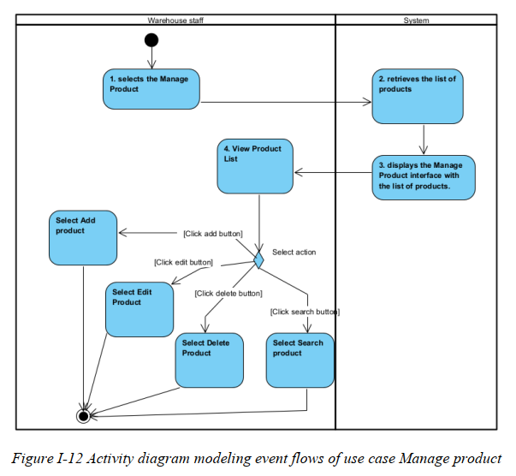
………

II.6 Entity Relationship Diagram
[Provide the entity relationship diagram and the entity descriptions in the table format as below]

III. Analysis models.

III.1 Interaction diagrams
[Interaction diagrams are a type of UML diagram that illustrate how objects interact in a particular scenario of a use case. They focus on the flow of messages between objects or components over time.
There are two main types:
- Sequence Diagram – Emphasizes the time-ordering of messages
- Communication Diagram – Emphasizes the structure and relationships between objects]

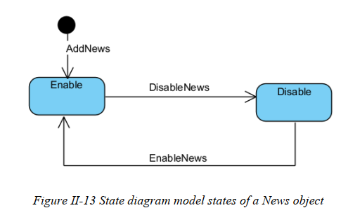

IV. Design specification

IV.1 Integrated Communication Diagrams
Sample
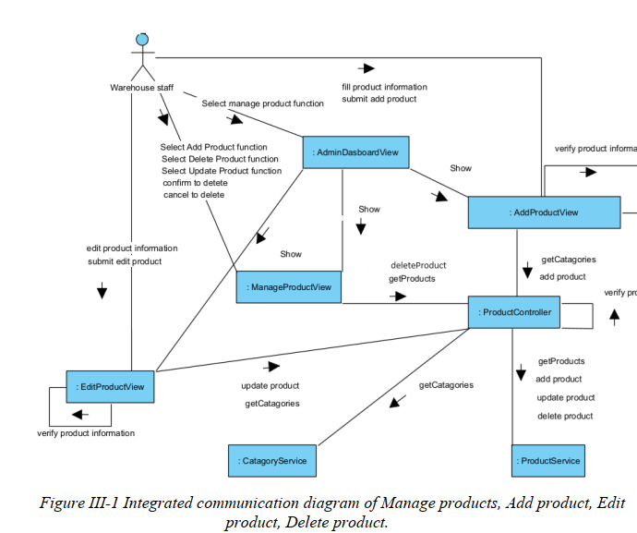

IV.2 System High-Level Design
Sample
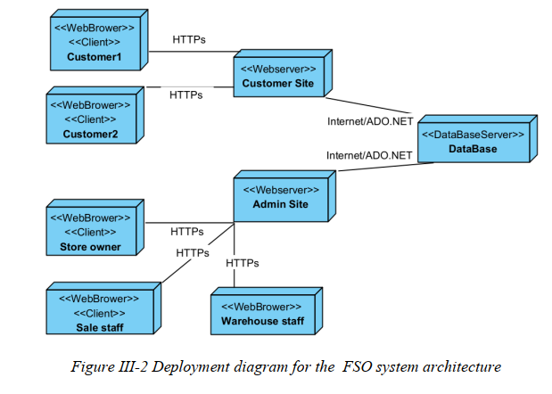

IV.3 Component and Package Diagram

IV.3.1 Component Diagram
Sample
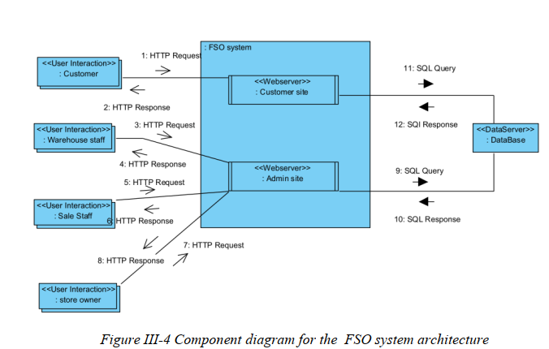

IV.3.1 . Package Diagram
[Provide the package diagram for each sub-system. The content of this section including the overall package diagram, the explanation, package and class naming conventions in each package. Please see the sample & description table format below (please note: package names don’t follow Java package naming convention yet)]
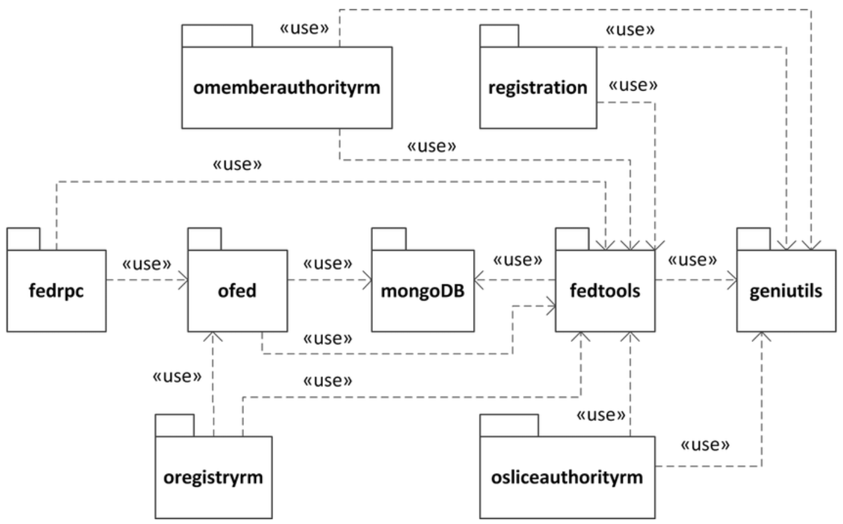
Package descriptions
No | Package | Description
01 | omemberauthorityrm | <Description of the package>
02 | registration | <Description of the package>
03 | fedrpc | <Description of the package>
04 | ofed | <Description of the package>
05 | mongoDB | <Description of the package>
06 | fedtools | <Description of the package>
07 | …

IV.4 Class diagram

- Overall
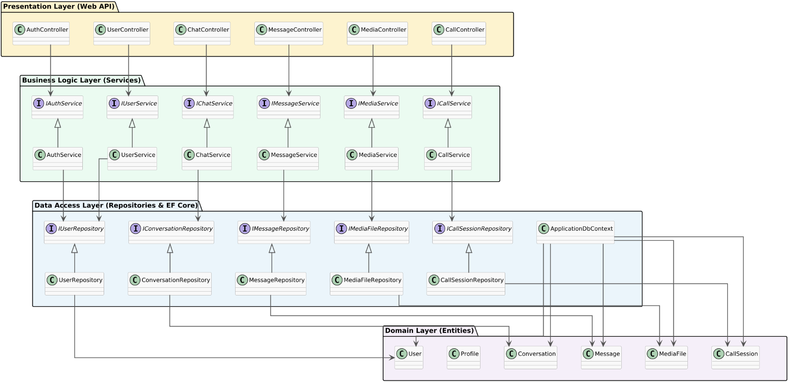

- Auth and User

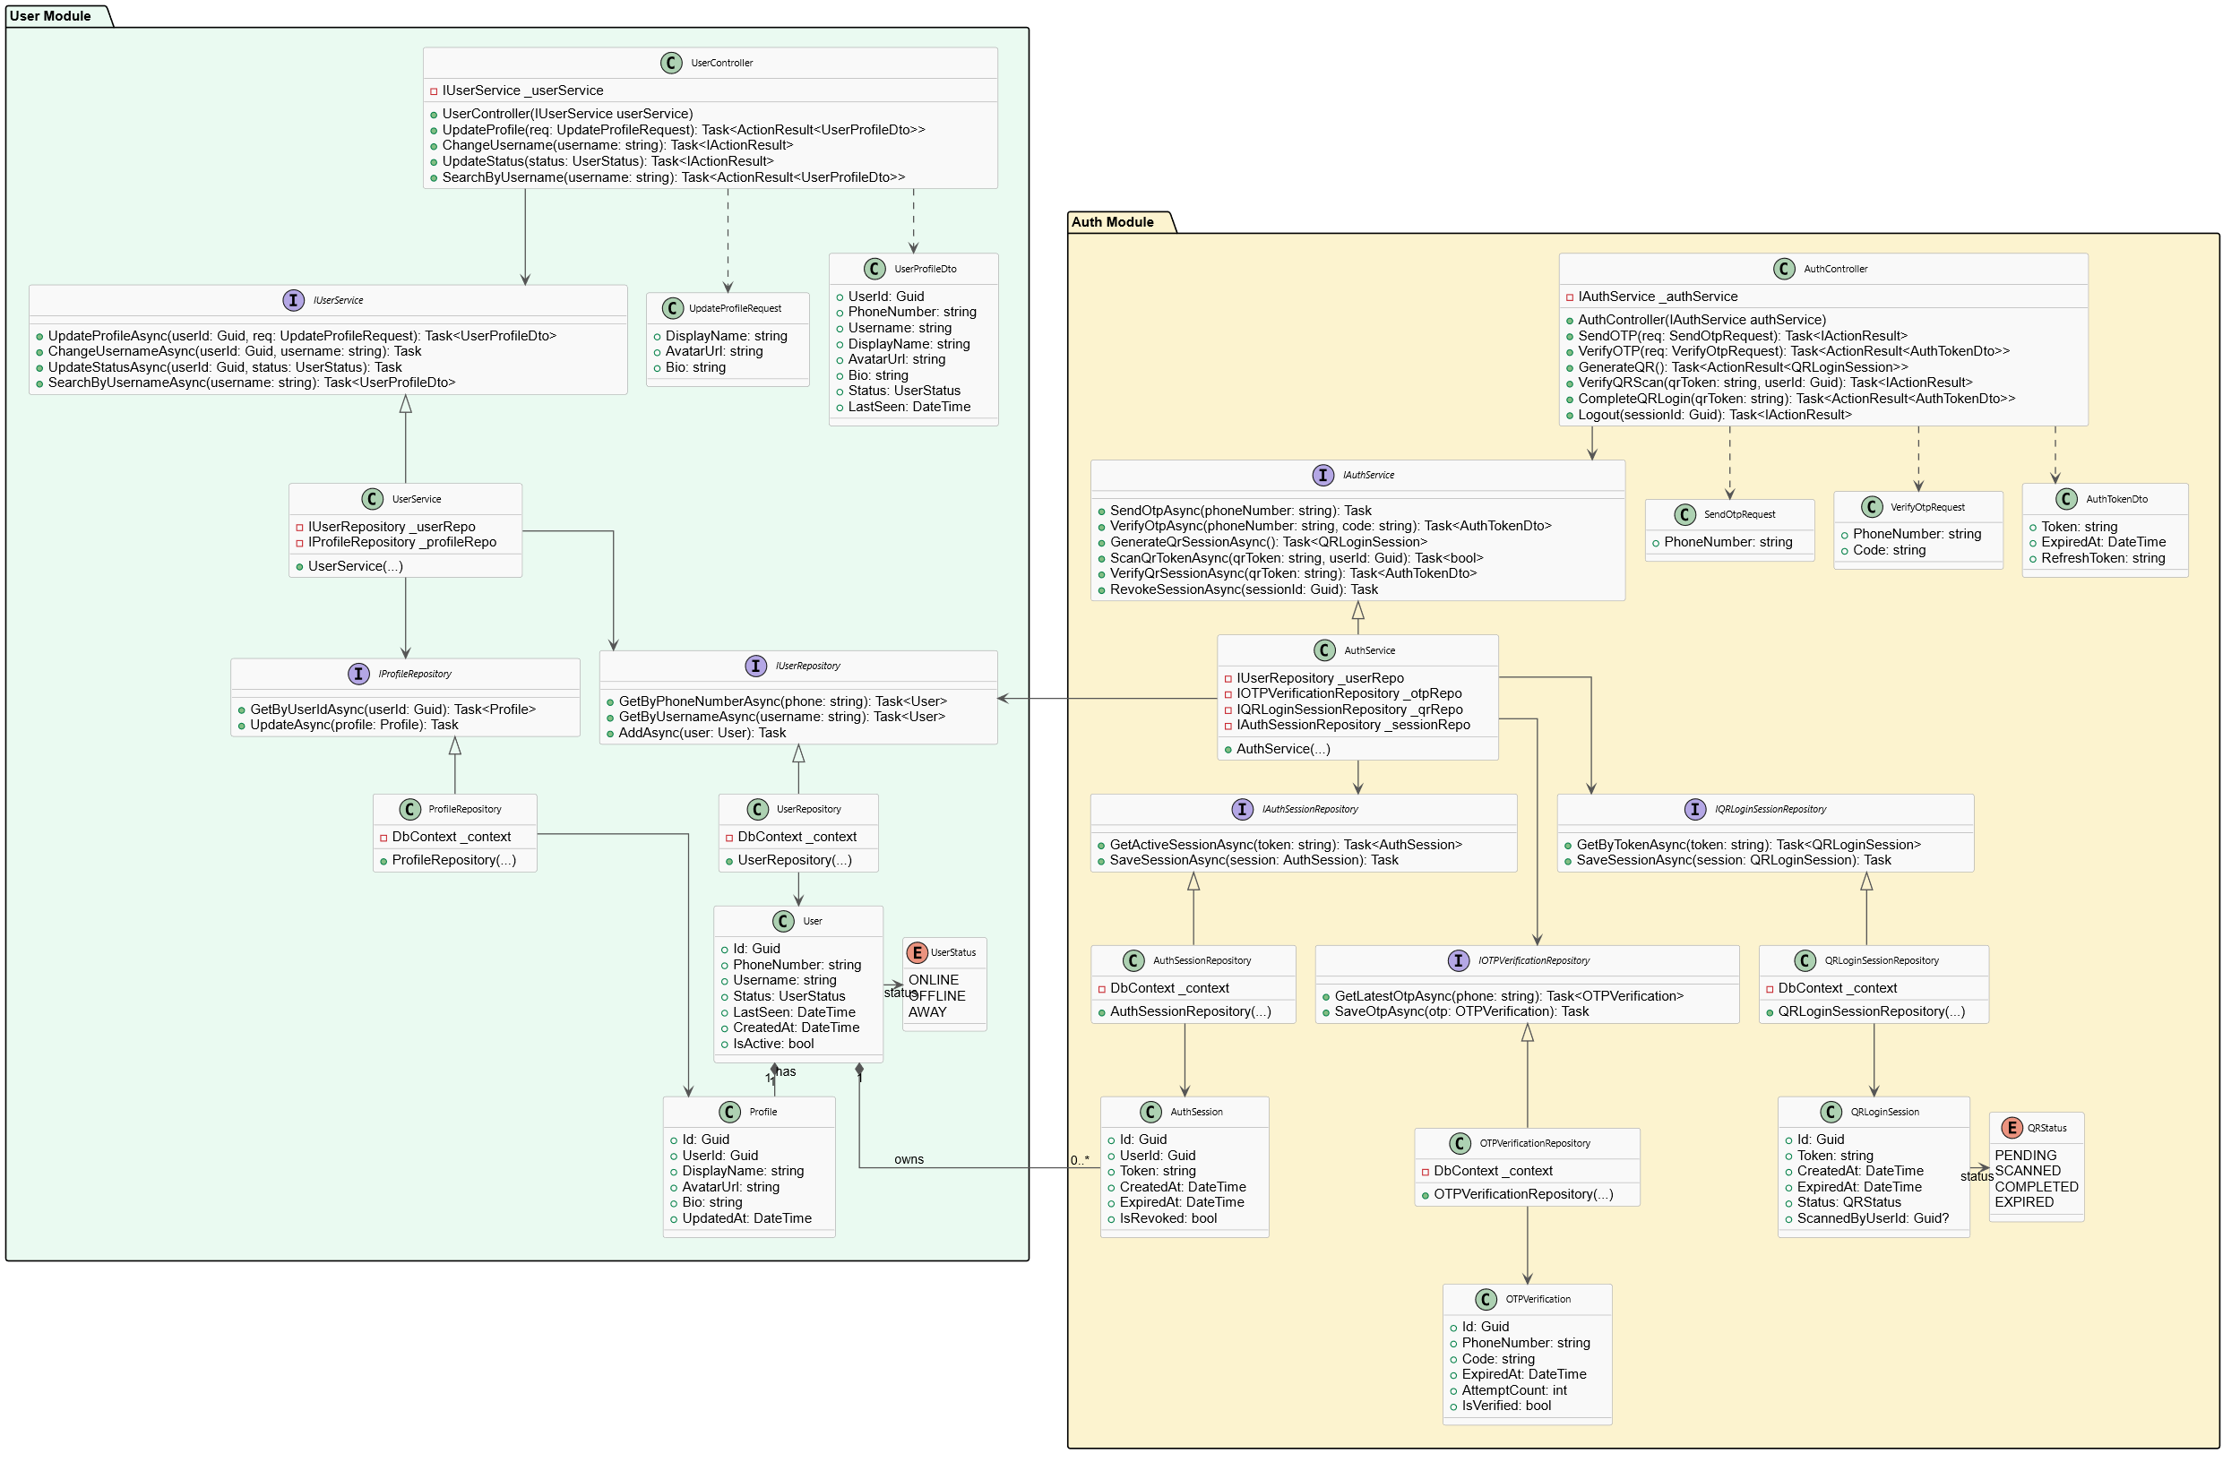

- Chat and Messaging
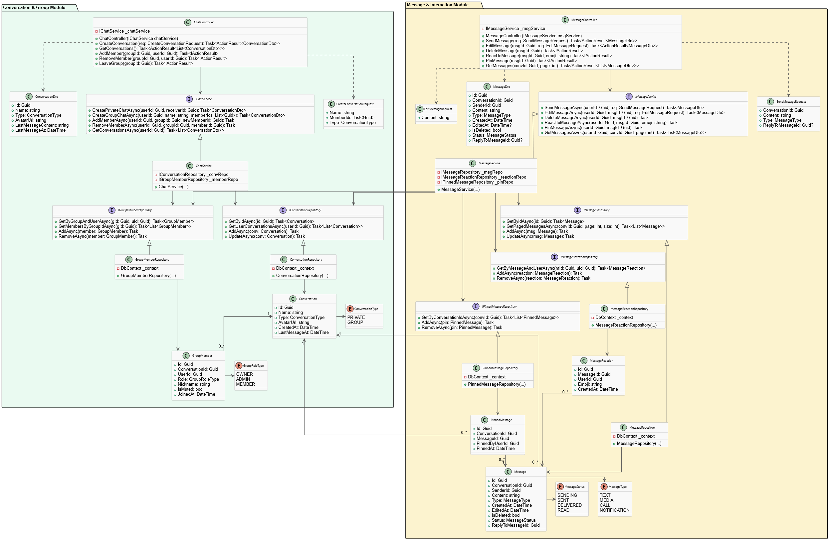

- Media and Files
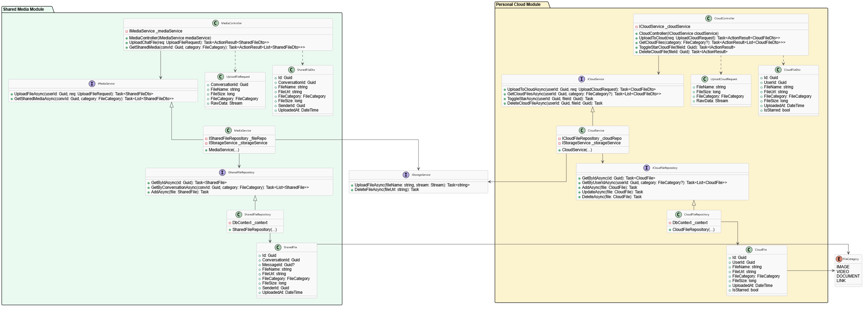

- Voice and Video Call
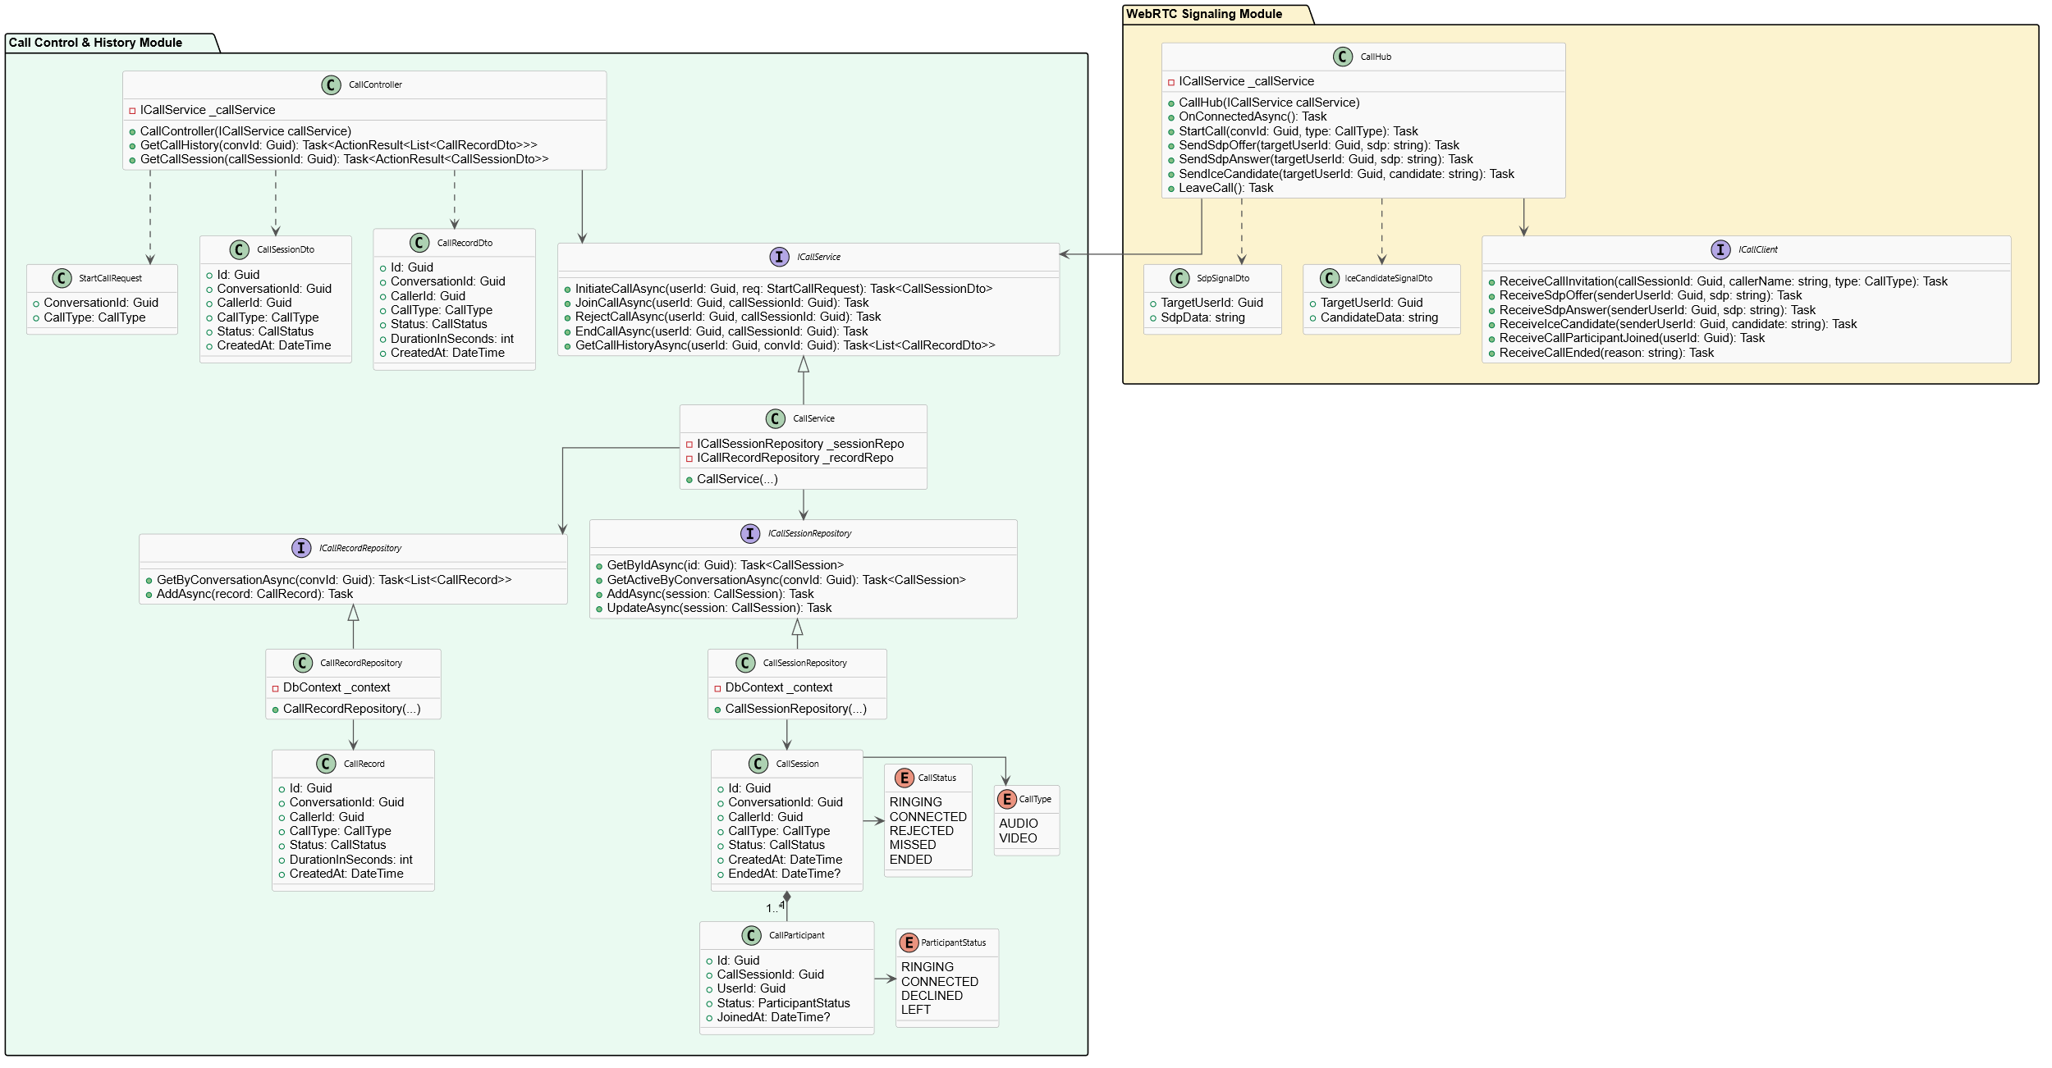

III.1.1.Sequence Diagram

[Provide the sequence diagram(s) for the feature, see the sample below]
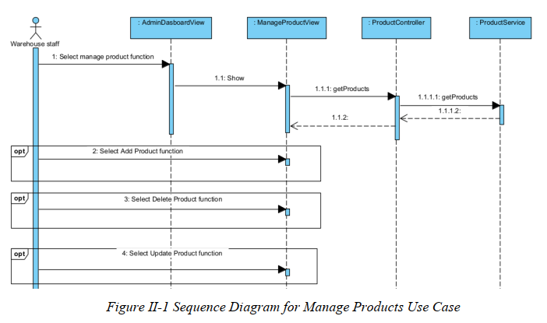

III.1.2. Communication Diagram
[Provide the Communication diagram(s) for the feature, see the sample below]

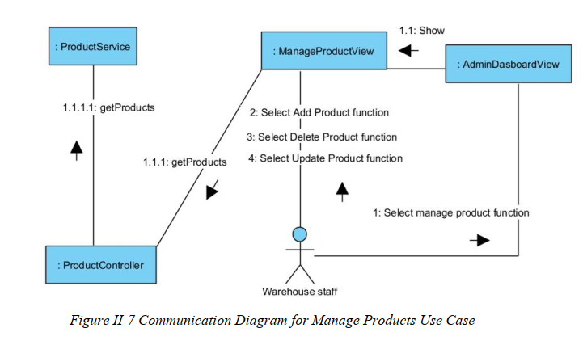

III.2 State diagram
[Provide the State diagram(s) for the feature, see the sample below]

IV.5 Database Design
[Provide the tables relationship like example below – following MySQL database naming convention]

V. Implementation

V.1 Map architecture to the structure of the project
[Provide:
- Overview of the Chosen Architecture
Briefly describe the architectural style (e.g., Layered, MVC, Service-Oriented Architecture)
Explain why it was selected for this project (e.g., to meet non-functional requirements like maintainability, scalability, reusability)
- Mapping to Project Structure
Present the actual project folder/package structure
Map each layer/component in the architecture to concrete project modules]

V.2 Map Class Diagram and Interaction Diagram to Code
[Demo the implementation of several features using design patterns]

VI. Applying Alternative Architecture Patterns

VI.1 Applying the ………….. (ex: Service-Oriented Architecture (SOA)) architecture
[Redesign part of the system architecture using Service-Oriented Architecture (SOA) to improve reusability, scalability, and modularity.
Students must provide:
- Problem Identification
Briefly describe which non-functional requirement(s) are not fully supported by the current architecture (e.g., NF-05: Reusability)
- SOA-Based Solution
Reorganize system components into independent services
E.g., refactor FSOData into separate service modules
- Supporting Diagrams
Deployment Diagram
Updated Class Diagram
Component Diagram showing separate services]

VI.2 Applying Service Discovery Pattern in the service-oriented architecture
[Support dynamic service registration and discovery in SOA or microservice-based architecture for horizontal scalability and ease of expansion.
Students must provide:
- Problem & Requirement
Explain the relevant non-functional requirement (e.g., NF-06: Scalability)
Describe the need for service discovery in a growing system (e.g., multiple branches, independent modules)
- Service Discovery-Based Solution
Integrate a Service Discovery Pattern
Mention possible technologies: Consul, Eureka, Kubernetes DNS
- Supporting Diagrams
Deployment Diagram (with multiple instances and registry)
Updated Class/Component Diagram including a Discovery Service]

